Studio Happenings____________________

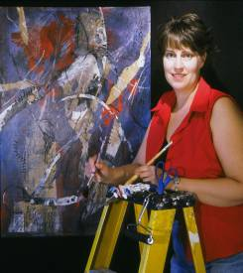
An Art Newsletter from the studio of Eileen Downes
I am excited to continue the publication of this bi-annual (November and June) newsletter concerning my artwork, my life experiences, and studio happenings;
I am eager to share such news with my friends, family, collectors, galleries, and
fellow art aficionados. I hope you enjoy the material.

Volume 2, June 2006

Selected Exhibition Highlights________

During the month of March, I was pleased to exhibit my God’s Beauty Series at 20th Street Art Gallery in Sacramento, CA (www.20art.net).
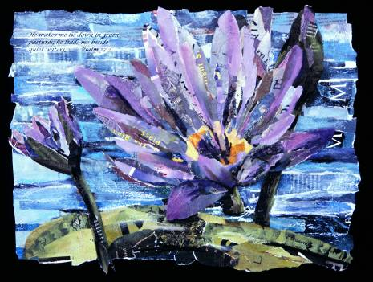
Artist: Eileen Downes
Title: Water Lilies
God’s Beauty
Series
Medium: Collage
Size: 18” x 24”
20th Street Art Gallery
Mixed Media Show

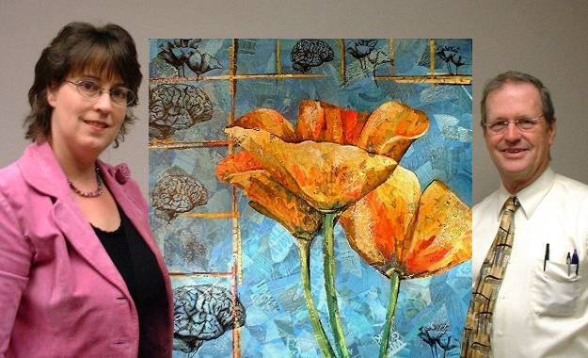
This series is a collection of layered collage paintings that embrace the splendor of flowers, and explore God’s creation by subtle incorporation of select Bible verses. It is my intention to glorify God with this artwork, and as an artist I have found intense personal satisfaction in the creation of these paintings. Pink Camellia was selected as cover art for the February 2006 edition of Inside the City, a Sacramento publication (www.insidepublications.com).
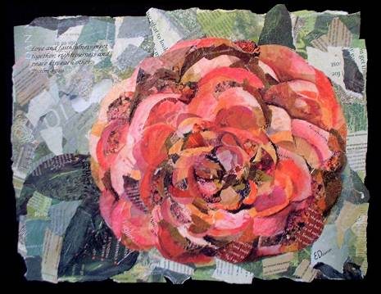
Artist: Eileen Downes
Title: Pink Camellia
God’s Beauty
Series
Medium: Collage
Size: 18” x 24”
20th Street Art Gallery
Mixed Media Show

The series was well received, and I plan to continue it as well as a similar series, God’s Bounty, focusing on fruits and vegetables.

In addition, I have been producing images for my Beauty and the Brain Series which is my way of honoring acclaimed US neurosurgeons for their compassion and tremendous strides made in the field of neurosurgery. The doctors are selected from nominations made by brain tumor support groups, patient advocacy networks, and referral organizations. Thus far, my collage paintings have been presented to
Dr. Cully Cobb of Sacramento CA and to
Dr. Ossama Al-Mefty of Little Rock, AR. The series is emotionally rewarding for me as my husband continues his battle with brain cancer.
Eileen Downes presenting collage painting to Dr. Cully Cobb

2006 has been busy with exhibitions in
Chico, Washington DC, Chicago, Belmont, and New Zealand. My new wax based collages were exhibited at both the Gallery West in Alexandria, VA (www.gallery-west.com) as well as the Woman Made Gallery in Chicago (www.womanmade.org). They are similar to my typical work except created using tinted, molten bee’s wax which adds a mysterious translucent quality. In my wax collages, layers of liquefied wax are spread and ironed onto the developing surface.
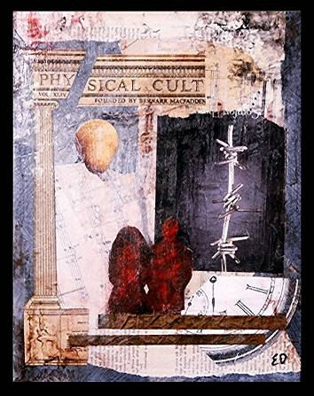
Encaustics or wax painting is an age-old technique dating from the 5th century BC, but it is a new medium for me. I enjoy discovering what interesting effects the wax can give to my collages.

Artist: Eileen Downes
Title: Marriage Fruit
Medium: Wax Collage
Size: 16” x 12”
Woman Made Gallery
Here Comes the Bride

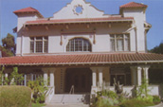
Peninsula Museum of Art
Belmont, CA

The February thru April Beaux and Eros Exhibition at the Peninsula Museum of Art (www.peninsulamuseum.org) in which I participated, was a thought-provoking show embracing the theme of love and relationships.

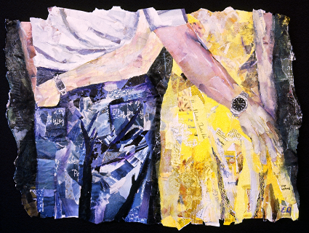
Artist: Eileen Downes
Title: Put a Little Love in Your Hip Pocket
Medium: Collage
Size: 20” x 25”
Peninsula Museum
of Art
Beaux and Eros Show

Announcements____________________

This year I was honored to be selected for the National Association of Women Artists (www.nawanet.org) which is dedicated to promoting women artists of all backgrounds and traditions. The N.A.W.A. participates in curated and juried exhibitions in New York City and nationwide.
On-Going Studio Creations________
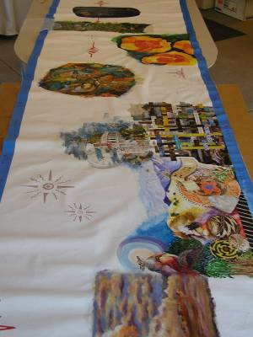
The California Society of Layerists in Multi-Media (www.slmm.org) cooperative art project is evolving nicely. Since its inception in April 2005 the canvas has traveled to participating artists all over California uniting us in spirit and creativity. It should be completed in the early summer of 2006. Watch for details of its future exhibition venue. Finally, we hope to donate the finished piece to the Sacramento Shriner’s Children’s Hospital to decorate their foyer hallways and give cheer to the patients and their families.
The cooperative art piece in progress

On A Personal Note______________
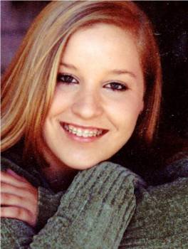
We are pleased to announce that our oldest daughter, Rosie graduated with high honors from Rio Americano High School this June, and plans to begin her college experience at CSUS. We are very proud of her as well as our other two daughters, and we look forward in anticipation to all that awaits their future.

Rosie, age 17

Favorite Artist’s quote of the week:
“A work of art which did not begin in emotion is not art.” Paul Cezanne

For more information contact:
Eileen Downes
5150 Fair Oaks Blvd. #101/319
Carmichael, CA 95608
(916) 761-0510
www.eileendownes.womanmade.net

