Studio Happenings____________________

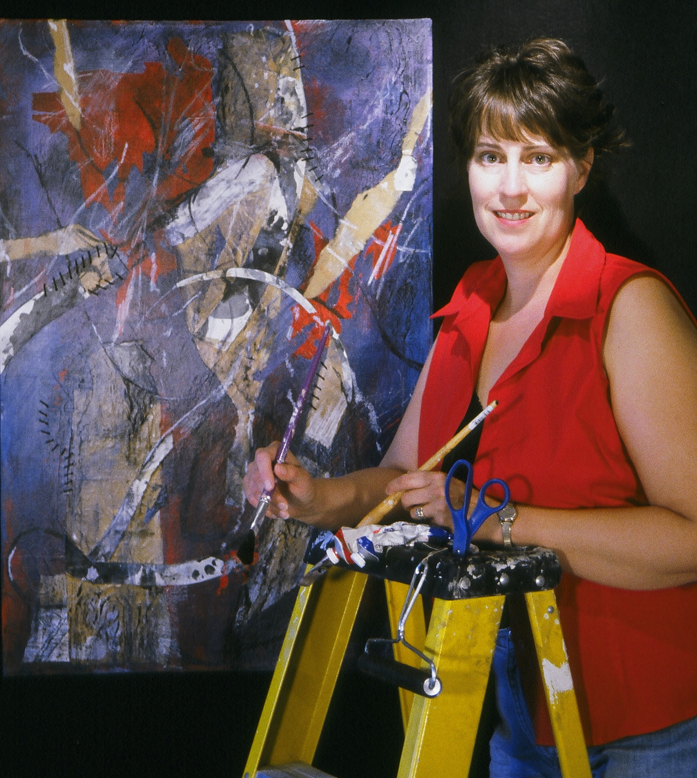
An Art Newsletter from the studio of Eileen Downes
I am excited about publishing this bi-annual (November and June) newsletter concerning my artwork, my life experiences, and studio happenings; I am
eager to share such news with my friends, family, collectors, galleries, and
fellow art aficionados. I hope you enjoy the material.

Volume 1, November 2005

Selected Highlights from 2005___________
This winter, I was honored to be chosen to take part in the Space & Spirit Exhibition at the Center Art Gallery, Calvin College, in Grand Rapids, MI. The exhibition represented a range of artist’s responses to the question: What is sacred space? The thought provoking exhibit was held in conjunction with the National Calvin Symposium on Worship and
the Arts.
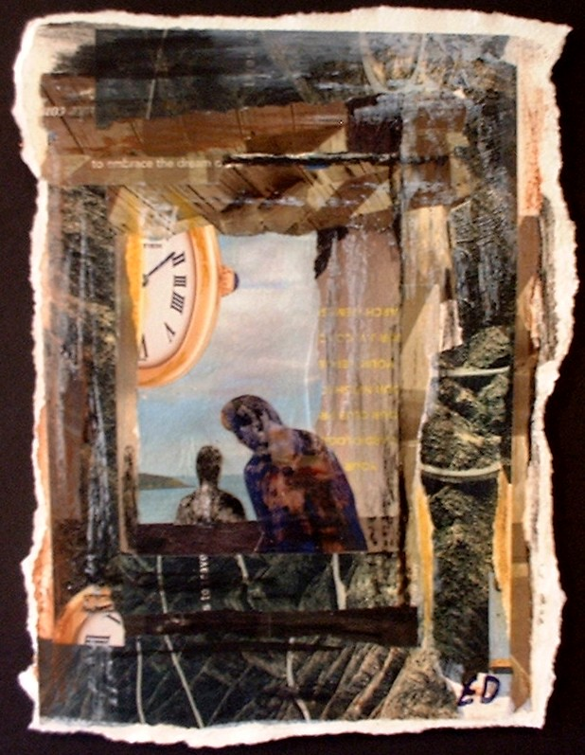
Artist: Eileen Downes
Title: My Visit With God
Medium: Collage/ Mixed Media
Size: 13” x 11”
Center Art Gallery, Grand Rapids, MI
Space and Spirit Exhibition 2005

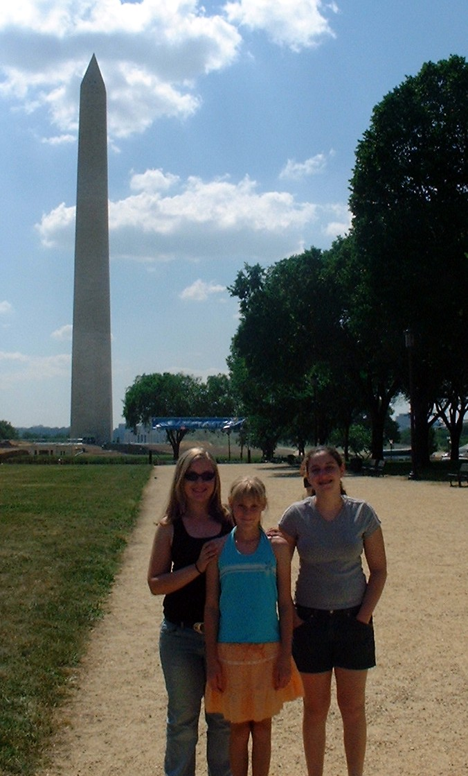
This summer we were very fortunate to be able to take a memorable vacation / gallery excursion to the east coast to attend the opening reception of On The Edge at the Peninsula Fine Art Center Gallery in Newport News, VA where I was showing work with the Society Of Layerists in Multi- Media (www.slmm.org). The exhibit was juried by Michael Preble, program director, and proved to be a diverse showing of edgy, layered artwork.

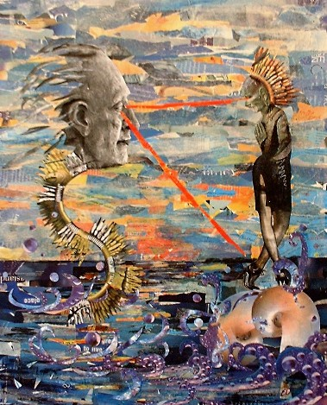

Artist: Eileen Downes
Title: The Ancient’s Vision
Medium: Collage
Size: 32” x 25”
Peninsula Fine Art Center, Newport News, VA
On The Edge Group Show 2005

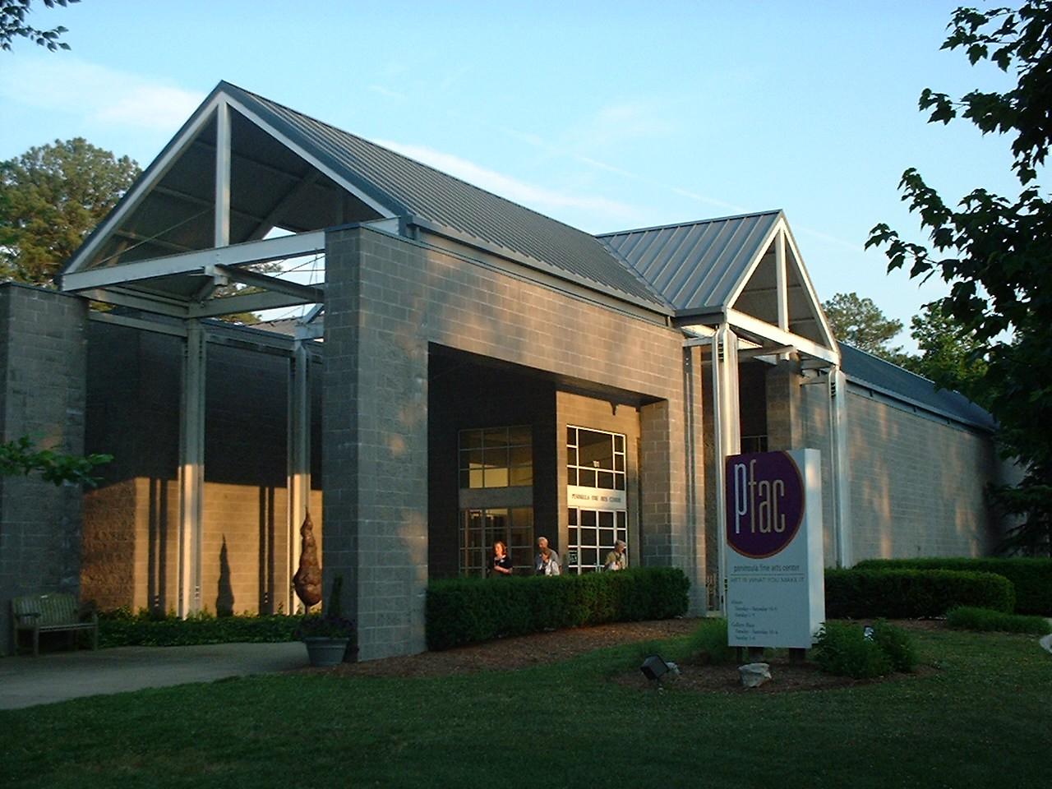

The Peninsula
Fine Art Center
Newport News, VA
(www.pfac-va.org)

While on the east coast, we not only enjoyed the artwork, and galleries, but also toured Colonial Williamsburg, Washington DC, and Busch Gardens Amusement Park. We experienced a fun, family vacation that was filled with adventure. I returned to my studio equipped with masses of photos, collage materials, and ideas from which to create.

Rosie, Carol,
and April
Washington DC 2005

This fall I was also pleased to be able to take part in two exhibitions held at Chicago’s WomanMade Gallery, a cutting edge gallery that is dedicated to raising public awareness and recognition of women artists’ cultural contributions. (www.womanmade.org) The Annual Member’s Show, and The Nature Of Paper both proved to be innovative exhibitions of American women artists’ work.

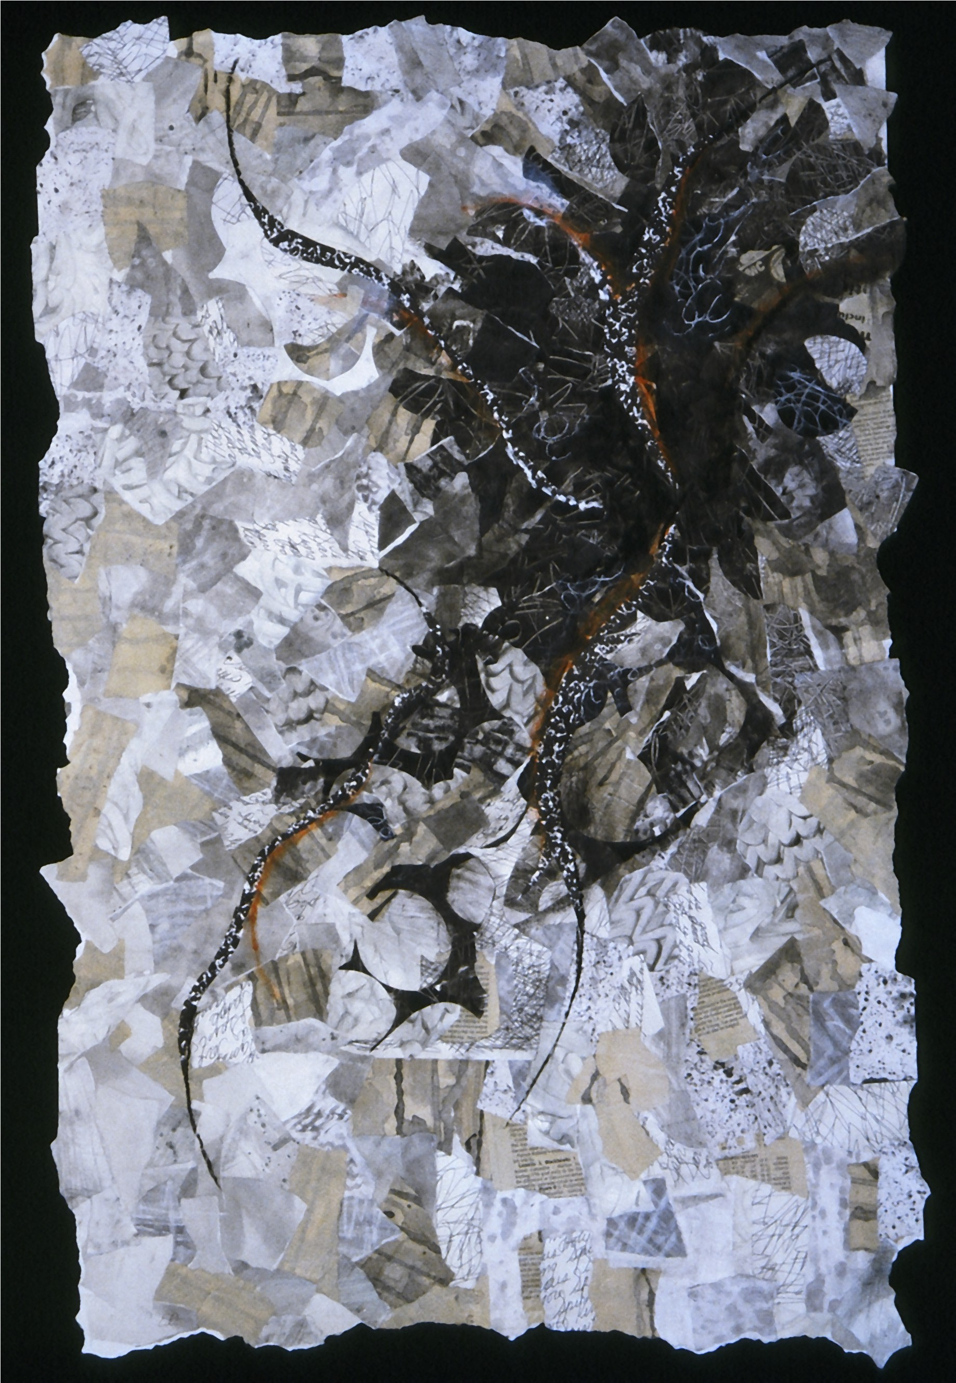
Artist: Eileen Downes
Title: Harmony of Happenstance
Medium: Collage
Size: 41” x 28”
Woman Made Gallery,
Chicago, IL
Nature of Paper
Exhibition 2005

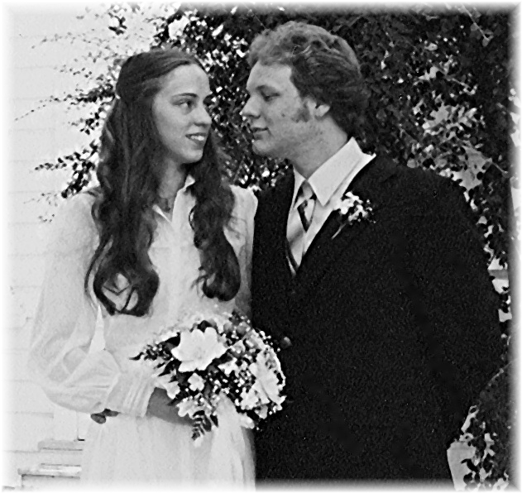
On-Going Studio Creations___________
I am excited to share with you my new artistic endeavors and visions. Currently I am producing a series of collage paintings: Beauty and Brains - 30” square canvas collages made from torn magazine papers, acrylic paint, and oil pastel.
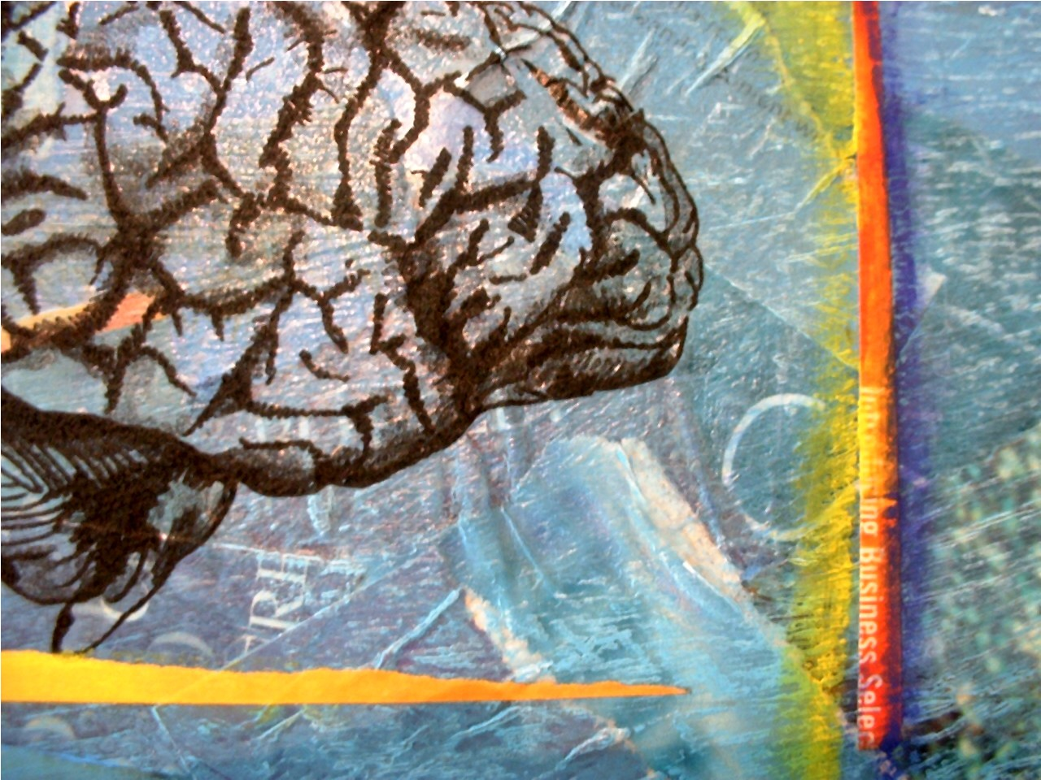
Close-up of image from
Beauty and Brains Series-
In Progress

The series deals with our perception of natural beauty, and also addresses the heroic strides made in the field of neurosurgery. I developed the idea for the series as a way to honor neurosurgeons, as I intend to gift select US neurosurgeons the artworks as my way of recognizing leaders in this dynamic medical field. I feel especially close to this artistic endeavor as my husband continues his battle with brain cancer. Watch for project updates in the June Newsletter.

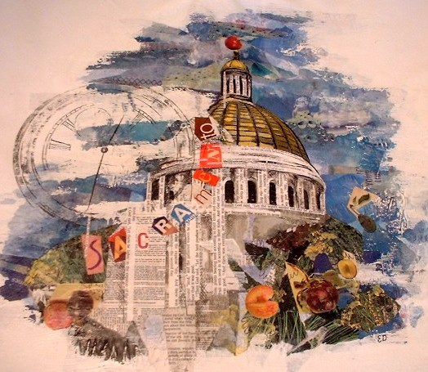
Artist: Eileen Downes
Part of the SLMM
Cooperative Art Project
Medium: Collage constructed from pages of the Bible, photos, and acrylic paint.

As an active member of the California Society Of Layerists In Multi-Media (SLMM), I have spearheaded a creative idea aimed to unite artists throughout California. Since SLMM embraces the premise that
artists possess an inter-connective spirit of thought, this cooperative art project echoes these ideals. The large canvas will travel to 26 artists throughout California, and each artist will add his/her creation to the evolving piece before rolling the canvas and shipping it to the next artist on the prepared routing schedule. Artists are participating from as far north as Crescent City and as far south as the Los Angeles Area. It is exciting to see how each artist interprets the theme of the piece: “California,” and how our artworks interconnect, overlap, and intertwine with each other’s. The project is developing nicely and should be completed by the spring 2006. We hope to exhibit the work for public viewing at the Falkirk Museum in June.

On A Personal Note______________

Scott and Eileen, 1980

My husband, Scott and I celebrated our 25th Wedding Anniversary in July. I can’t believe it has been that long – time flies when you’re having fun! We have been greatly blessed.

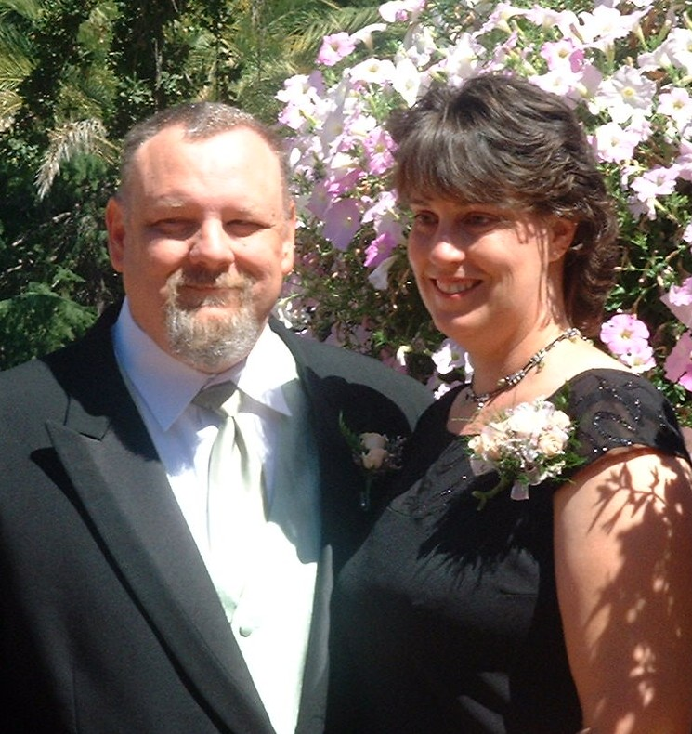
Scott and Eileen,
25th Anniversary

We were honored with the presence of many treasured friends and family at our celebration gathering.

Favorite Artist’s quote of the week:
“Art washes away from the soul the dust of everyday life.” Pablo Picasso

Eileen Downes
730 Howe Ave Ste 800
Sacramento, CA 95825
(916) 761-0510 Email:eileen@californiacpa.com
www.eileendownes.womanmade.net

