So You Want To Be An Artist
By Joan Waters
photography by jasoncarpenter.com
Advice from regional pros about selling your work and surviving the process.
If you’re an artist, sooner or later, it happens: Your artwork outgrows your capacity to keep it, hang it, give it away, stash it or store it under the bed. If you want to keep producing, you’ll want (and need) to start selling. While there’s no one-size-fits-all strategy, the good news is you love your work, you don’t wither under (fair) criticism and you know that even Georgia O’Keeffe had to start somewhere.

First Things First
“I think the most important thing for an artist to know is that they can’t approach any gallery without a body of work,” says Shirley Dubnick of Solomon Dubnick Gallery in Sacramento. “Often artists come in with a potpourri of work and they want to know how to market [it]. But that’s not really the way to approach a gallery. Galleries like portfolios that are organized.” And while you may want to include a landscape, a portrait of your son, an abstract and your version of French impressionism, Dubnick has two words for you: “That’s deadly.” Other parts of a hypothetical conversation with her could go like this: “I might say, ‘You paint nicely. Tell me what you like to paint. If you like to paint portraits, then go paint 100 portraits, and then maybe you can bring them back and let me see what you’ve done.’”
Mick Sheldon, artist, art instructor at American River College and director of the on-campus James Kaneko Gallery, seconds that. “I talk to students a lot about a continuity of work,” he says. “Now, that doesn’t mean you have to paint the same damn apple over and over again; what it means is your work should look like your work. So many students throw in all different kinds of work to show the gallery they can do a lot of stuff. Well, the gallery doesn’t care. They want to be able to sell a body of work with your look.”

Seeking Your Niche
Your paintings, sculptures or ceramic pieces are not going to fit in everywhere, so look for a gallery that has what artist and Sacramento City College art instructor Fred Dalkey calls “sympathetic tastes.” If you paint plein-air river-scapes, for example, don’t try to sell a gallery that features abstracts. “There are some galleries where the work won’t do well at all and others where it might do very well,” Dalkey says. So take your time and focus your search.

Presentation Is Everything
When you find a gallery where you think your work will fit, plan your approach. You could walk in with your portfolio under your arm, but you’ll probably find a warmer reception if you first send a letter introducing yourself and your work. Yes, enclose slides or a CD of images along with your résumé and an artist’s statement. “Avoid going into raptures about the meaning of your life and art,” Dalkey says. “That’s a fairly good way of showing you’re an amateur. Include a brief résumé of where you’ve shown, shows you’ve been in and—this is important—why you’re interested in that gallery. Then ask them to please consider the work and include a self-addressed envelope so they can send it back.”
Sheldon, whose colorful woodblock prints are represented through Exploding Head Gallery in Sacramento, likes the idea of putting your whole presentation on a CD. “It’s like a traveling website,” he says. “I can put a series of images on there, a résumé, an artist’s statement and an introductory page with thumbnails.” (The photo lab he recommends for performing this digital magic is Cali-Color, 191 Lathrop Way, Suite H in Sacramento.)
OK, now you’ve submitted. What’s next? You wait. “You can call them in about a week. That says you’re doing your job as an artist,” Sheldon says. “But if you push, they may stop looking.”

Mingling With a Mission
Seeing, and being seen, is crucial to getting your art career off the ground. You should be going to as many galleries as you can as often as you can. “You can’t be in the game if you’re not in the game,” Sheldon says. “It’s simple. You walk in every month and say, ‘Hi, how are you doing?’ You really don’t need to say anything other than that. Pretty soon, gallery people will start talking to you and asking you about your
work.”
That’s exactly how Sacramento native Kim Squaglia introduced herself in 2004 when she returned home from Cape Cod, Mass., bearing a master’s degree in fine art, a cohesive body of work, a curriculum vitae listing shows in Houston, San Antonio and Los Angeles, and a rave review from the Los Angeles Times. “While there were a couple of galleries where I knew I wanted to go, JayJay was obviously the best fit,” she says. “I started going to openings and talking to them, but not necessarily as an artist.” Later on, she says, she dropped by and asked the East Sacramento gallery owners if she could show them her work. She knew it was a good sign when they asked if they could “hang on to” a few pieces. “Lucky for me, Lial Jones (director of the Crocker Art Museum) really liked my work and she bought a couple pieces,” says Squaglia. “That was a wonderful ushering into the art scene, for sure.”

Who Do You Know?
No surprise here. It’s all about who you know. If you know someone with clout in the local art community, ask them to approach a gallery for you. (That’s what Georgia O’Keeffe did, by the way: She mailed her drawings to a friend, who showed them to famed photographer Alfred Stieglitz.)
Sheldon says he introduces at least 10 new artists into galleries every year. “Because I’ve also shown work in almost every gallery in town, I know a lot of people,” he says. “I help a lot of artists because I know that’s how it works. A lot of people helped me.”
But going it alone can work, too. “There are people who do very well hitting galleries cold,” says Dalkey, whose work is shown through the Paul Thiebaud Gallery in San Francisco. “I can think of a particular artist, Tom Leaver, who sent slides all over the place and hit a very good gallery in New York that said, ‘Yes, we are interested in working with you,’ and that came out of nowhere. It can happen.” Leaver, who works in the Bay Area, had a show at JayJay this past winter. “He was sending things out all the time and getting rejected,” Dalkey says. “That’s something very important to realize. Just because you’ve been rejected doesn’t mean there isn’t a place for you.”

The Artist as Businessperson
“Oh, boy.” That’s what Dubnick remembers saying when she first saw John Tarahteeff’s portfolio. “He was a very mature artist at a very young age,” she says. What may have been even more important was that he presented himself as a professional very early in his career. His engaging, mysterious and narrative paintings have been represented in Sacramento through Solomon Dubnick Gallery since 1998; Tarahteeff also e-mails images and slides—and sometimes even ships his paintings—to galleries across the country so they can take a look. “Rejection doesn’t hinder me,” he says of his not-always-successful attempts. “I expect that. I know how it is. Even if your work is good, it might not be a good fit. You have to respect the gallery when they say, ‘This is serious work but it doesn’t fit with what we’re trying to do.’ It’s part of the business. Art is business.”
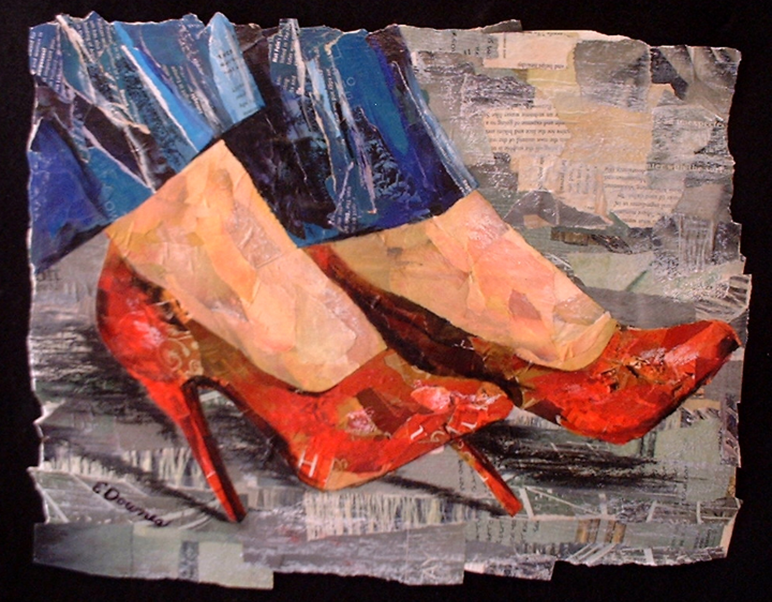
That’s how Sacramento collage artist Eileen Downes sees it. While some artists struggle with the business side, Downes takes a realist’s approach. “I find being successful involves a lot more than talent,” she says. “You have to be a business-minded professional. Everything you do marketingwise has to fit your plan. It’s important to tell people you’re an artist. My e-mail has my website and tells people what I do—that I’m an artist who paints with torn paper.” Recently, Downes received a commission while she was making reservations at a local bed-and-breakfast inn. “The owner looked at my website, liked my work and commissioned a large piece,” Downes says. “You don’t always know where your business is going to come from.”
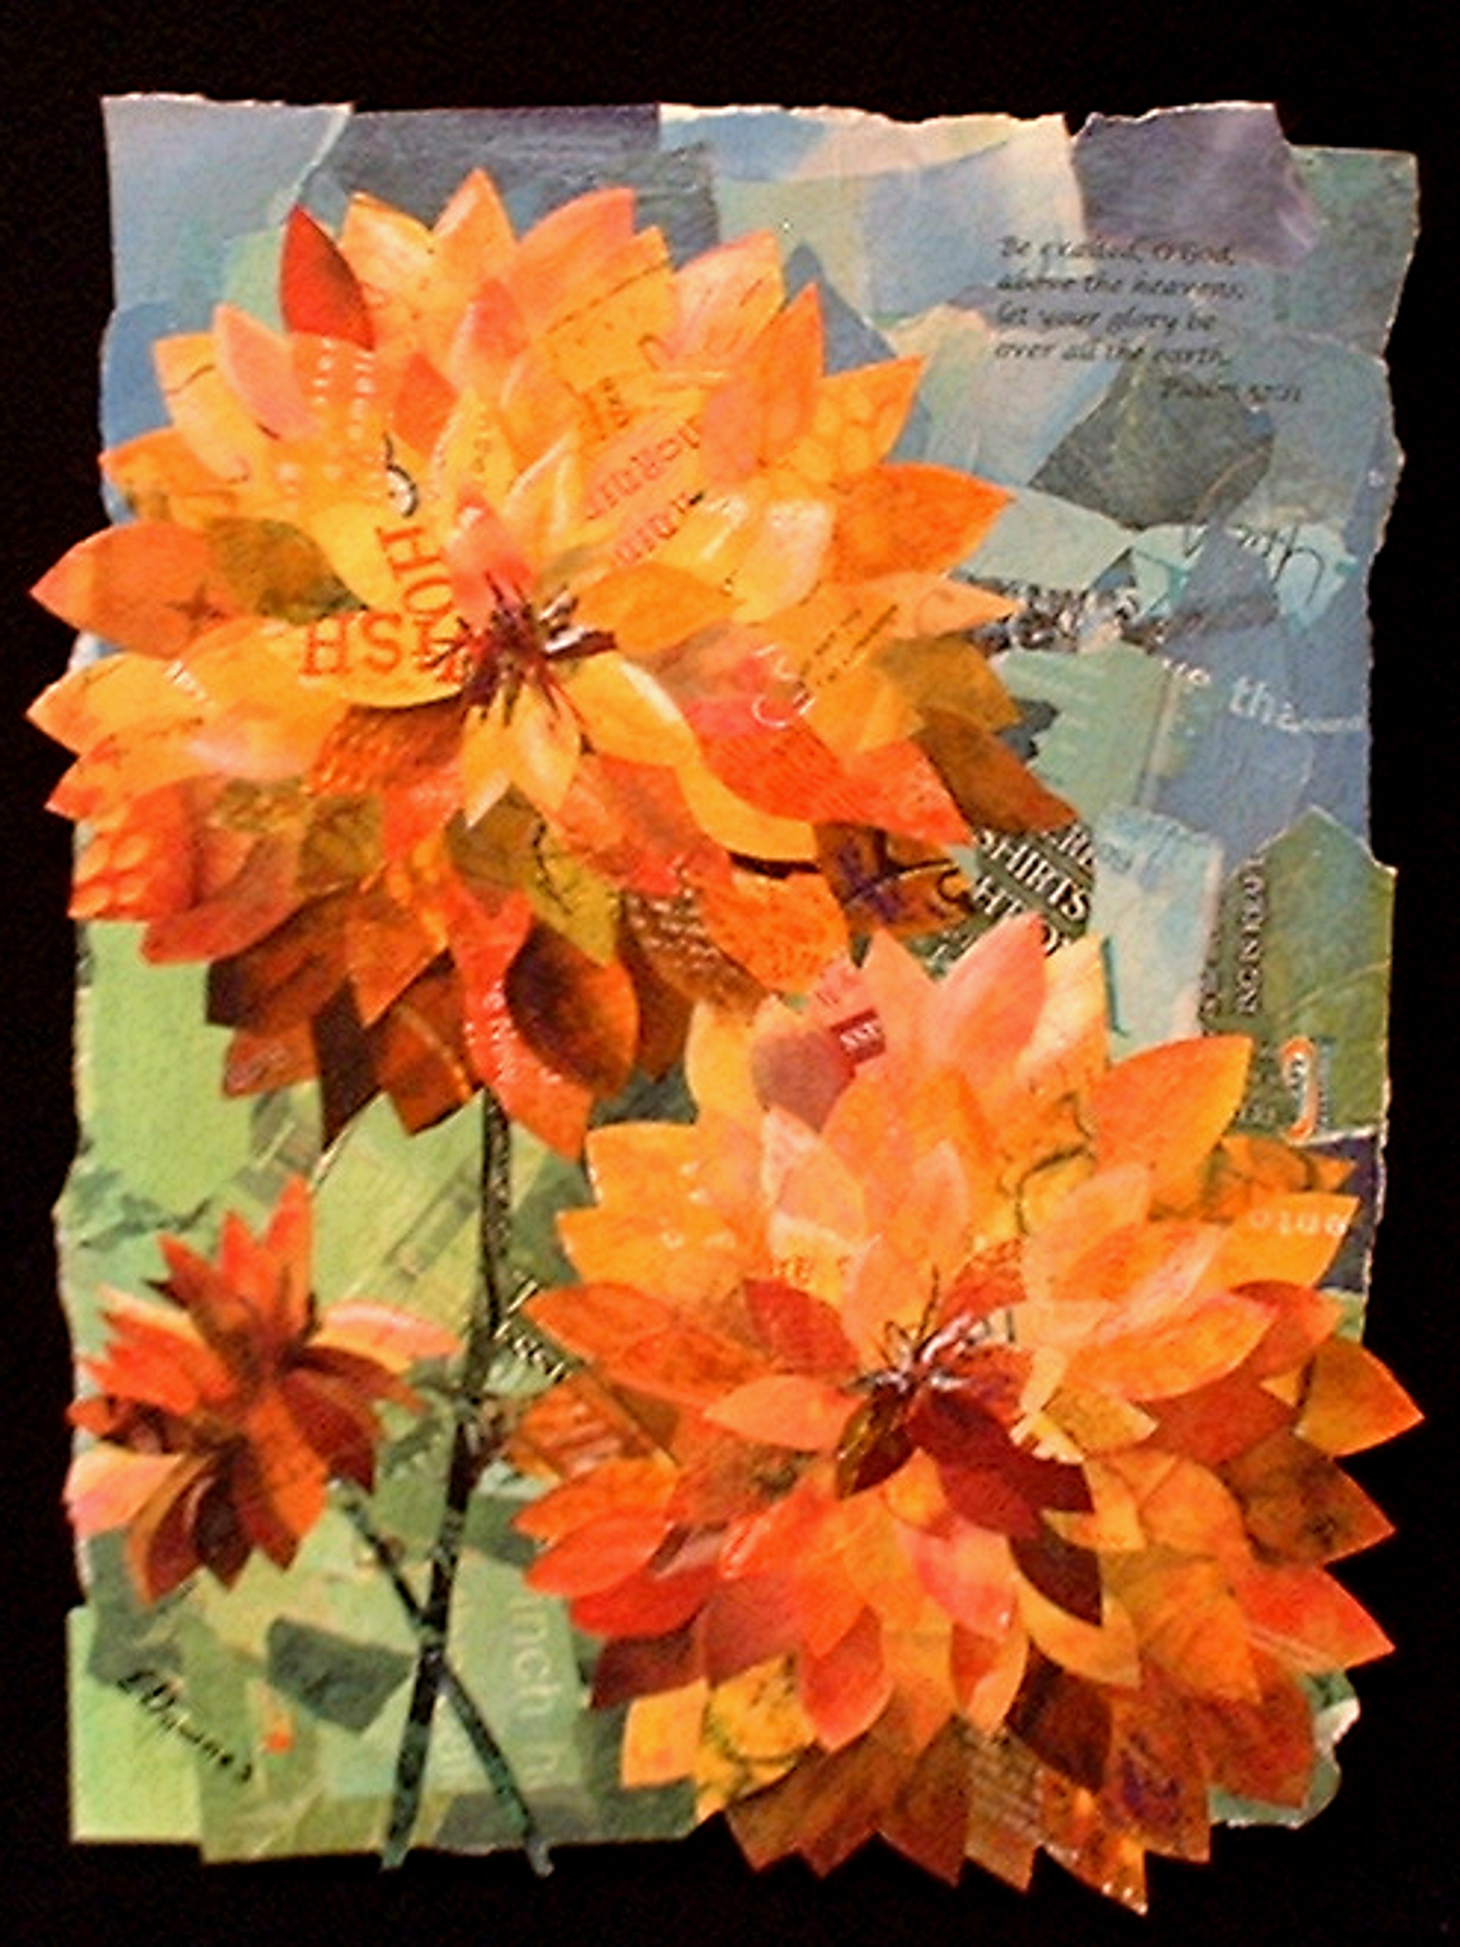
My Favorite Red Heels, by Eileen Downes
Sunny Dahlias, by Eileen Downes
Stephen Simonson, gallery manager at 20th Street Art Gallery in midtown Sacramento, calls Downes a “dream artist.” “She is doing a lot to try to make it happen,” he says. “She comes in with a passion and a drive that makes the gallery want to do more for her.”

Juried Exhibitions
It’s tough to pry open the door to a gallery without credentials or a sponsor, so why not add a little weight to your résumé by entering a juried exhibition? “Not only can you win money, but you can get a lot of exposure,” says Squaglia, noting that a $4,000 prize she won in a juried exhibition in Houston was “the best thing that could ever happen to an artist just out of grad school.” She recommends checking out Artweek magazine or subscribing to a newsletter published by artdeadline.com to get the scoop on competitions and what you have to do to enter.

How Not To Give Up
There are lots of ways artists can make money while they look for a market: teaching, museum work, art consulting, gallery ownership, graphic design. In truth, a day job can carry you through the lean years. Just like in any profession, persistence pays. “I just had to walk around with a portfolio and send out slides,” says Gary Pruner, one of Sacramento’s most celebrated art instructors and well-known artists. “You’ve just got to do it. Maybe one out of 50 galleries will have you leave your work for a week or a month. Wall space is money and if it doesn’t sell, they let you go, and you go on to find someplace else.” Eventually, Pruner says, his phone started ringing, “but that was after years and years of not really getting anywhere with it.”
Sometimes Squaglia says she wishes for a career with a little more structure. “Believe me, there are many times a year I stop and say, ‘OK, I’m getting a real job,’ even though this is a real job. . . . It’s great when you get a commission, but other times you’ve gone three months without selling anything. Artists don’t have the luxury of having benefits and medical insurance and that kind of stuff. We do these things because we love doing them. Sometimes I do wish for something with more structure, but really, I wouldn’t trade this for anything.”

Sell Your Work, Keep Your Integrity
Pricing can be a powder keg of an issue for some artists. “You want it to be expensive enough so people know you value your work, and not so cheap you’re giving it away,” says Stephen Simonson, gallery manager at 20th Street Art Gallery. “You also have to be consistent in your prices, especially as you build up clients and people are following your work. Say they purchase a piece from a gallery for $300 but can then buy a piece from your studio for $50. It lessens the value of the purchase. If the artist says, ‘Here, I can give you a deal because I’m not paying a gallery commission,’ it ends up damaging them in the long run because their price point has dropped.”
Established artists also warn that while donating artwork to fundraisers can definitely get your name out in front of the public, it also can make a potential buyer hold back on a purchase, thinking he can get a better deal when your work comes up at auction.

What the Artist Does, What the Gallery Does
While you may gasp when you learn a 50-percent commission is fairly standard in Sacramento, remember that a good gallery works for its money. Yes, they buy the light bulbs and office supplies and paint the pedestals and mount the shows, but that’s not Job No. 1. Advertising and promoting you as an artist is. “I keep alert,” says gallery owner Shirley Dubnick. “I’m always looking for ways to get [the gallery’s artists] promoted. I tell them to ‘try this competition’ or ‘look into this gallery.’ I’m not afraid to promote my artists in other areas because I know it’s going to come back to me. I’m going to be the home gallery, and I’m going to be as much an asset as is possible.”
What are your responsibilities to your gallery? “The artist has to be there on time, with the work, ready to hang and framed well,” artist, art instructor and gallery director Mick Sheldon says. “And if the artist has agreed to hang a show, say from the first of April to last of April, they can’t take their work out a week early because they think they have a better show someplace else.”
Once you have a good relationship with a gallery, maintaining it probably means you don’t show in another gallery in the same geographic region or sell work right from your studio. “Although I do not have an exclusive contract with 20th Street Gallery or any other gallery—and I caution artists never to sign any totally exclusive gallery contract—for any local sales of my originals, I like to refer my collectors to the 20th Street Gallery for purchase,” says collage artist Eileen Downes. “If the buyer is out of the area, I try to match them to another gallery that could sell my work—for example, the Woman Made Gallery in Chicago. I think it is better to use a gallery for the sale of my originals, and working like that always encourages good artist/gallery relations, which is very important to the success of the artist.”

Listening to the Voice Within
When Gary Pruner first started showing his radiantly colored canvases in 1960, people constantly told him to “tone it down, tone it down.”
“They would say, ‘I can’t put that bright thing in my house,’” Pruner recalls. “Most people then would have a beige rug, beige walls, a beige couch, and then they’d have a powder-blue flower. Now, if they look at my paintings, they say, ‘Ah, my fuchsia couch and chartreuse drapes would make that painting look dull.’ And I say, ‘Really?’”
So the message is, while you can politely listen to people drone on about your work and learn what you can from it, you don’t have to change. “You can get torn,” says Pruner, whose brilliantly hued paintings now hang in museums and corporate and private collections throughout the world. “Oftentimes, younger artists jump into emulating someone who’s doing well, and I don’t think that’s wrong, but as you mature, you get a better insight into what you prefer as opposed to what everybody else likes. Something inside me was fascinated by color work, but it wasn’t really accepted. Today, I can’t go in a gallery without seeing brightly colored images everywhere.”
Creating your own style and resisting the temptation to follow trends can pay off in a big way. “People who own galleries probably see more art in a month than most of us see in a lifetime,” Pruner says. “Their ability to scrutinize what has power and what doesn’t is far more exacting than the average person’s. So to get up into that realm with Wayne Thiebaud, say, you have to paint a lot. And you have to learn how to believe in yourself and be as strong as you can.”

Straight to the Source
Ceramist and instructor Donna Billick has always wanted to run her own show and pretty much has since she began her career 28 years ago. Known for her larger-than-life public art installations in tile, cement and stone, Billick says she’s rarely experienced lack of opportunity—or funding. “I’ve shown in San Francisco, Los Angeles, New York, a lot of different galleries, but I always felt like somebody else
was a little bit in charge—especially about when you showed and what kind of things they wanted to represent.”
At the core of Billick’s drive to have an “art-centered life” is her desire to create works seen by thousands of people rather than a few private collectors. “I wanted to go to the public sector,” she says. “I made multiple trips to Europe, learned terrazzo, learned mosaic. I learned tile, so I took on that learning curve, and then I was interested in taking that to large-scale public art forms. When public art agencies began making projects available through RFQs (request for qualifications) proposals, that’s the train I got on.”
Is that a viable option today? “Hell, yeah,” she says. “Also, private developers have seen this public-art movement unfold and have been prodded and incited to do the same—make public art available,” she says. Case in point: the tile mural on the OfficeMax building at 17th Street, facing J Street in midtown. That’s Billick. “I think developers are really picking up the ball,” she says.
Studying and working at UC Davis with Robert Arneson, one of Northern California’s mightiest names in ceramics, gave Billick a strong start, but she still had to get traction in the public/private sector for her career to really take off. So she and two colleagues made a “little sweep” through the offices of Sacramento architects. “We said, ‘We’ll provide you with a little lunch, and we’ll show you what we do.’ We did a couple of those every month for about two years, and it was extremely successful. From there, I started getting private developers and designers and anybody who was putting ‘space and place’ together. I think as long as you are willing to reach out, there’s a ton of money available.”

Working On the Other Side of the World
In 1990, Rod Larson-Swenson quit his job with the U.S. Postal Service in Oakland, moved to
Sacramento and began full-time work as an artist. Sacramentans know him best, perhaps, for his otherworldly “Bob the Dog” paintings and murals, which at one time enlivened at least three buildings in midtown and North Sacramento. In 1996, Larson-Swenson and his wife, LizAnn, left Sacramento for Taiwan, and in 1999 they moved once more—to the Yunnan Province in the People’s Republic of China, where she teaches English and he paints. Larson-Swenson has returned to Sacramento every summer for the past five years to hang a show at 20th Street Art Gallery in midtown Sacramento. His next show is scheduled for August.
By Rod Larson-Swenson
I started painting and drawing in 1970, the year my oldest daughter was born. I’d done a lot of looking (at art) before that but never felt that I could be a painter myself. The birth of my daughter suddenly made me feel that I could give it a try. That same year, my sister-in-law moved to the East Coast and gave me her old box of paint tubes and brushes. I started taking classes and attending life drawing sessions and poking around in the galleries and museums of the Bay Area. My early efforts were pretty terrible and unpromising, but I was hooked on the process and the community. Learning to draw was the first big challenge. I was slow but persistent.
Everybody was focused on how to sell stuff. We did lots of shows in cafes and performance spaces, and every once in a while something would sell. I didn’t get the feeling that I could live on what I could sell, but I loved working so I kept at it. I was working as a mailman, and I always carried a sketchbook and tried to draw every day. In 1990, I quit and tried to live on my painting. My income plunged from over $30,000 to around $7,000. That made me nervous, but I just kept at it because I really like painting, and every once in a while I’d get one that seemed really good. I guess the biggest potential pitfall was the fact that stuff just didn’t sell fast enough, but doing what I liked to do was enough compensation to keep me going.
I had lots of great mentors, a vast community of people who were working at art. Some were teaching; some were just barely managing. We were bound together by our love of painting and the presumption that we could do it and that it mattered. I owe everything to that community. They are as important as the work itself.
In 1996, I moved to Taiwan and in 1999 to Yunnan Province in the People’s Republic of China. My wife wanted to return there to teach English. I stopped painting for a year to work on learning Chinese. To my surprise, I found that I loved living in Asia. In the United States, we live a very internal, contained life. We are always in our cars or our homes or our workplaces. The sidewalks tend to be empty. In China, the sidewalks are packed with people in all conditions employing every conceivable means of transport. It’s a fantastic jumble of humanity. For me, there is something very comforting about the constant presence of people on the street. I love it. The economy is exploding, but the art market here is just beginning to develop. I can afford to hire people to sit every day, so I spend an hour a day drawing people. It’s wonderful. There is nothing as exciting for me as trying to capture someone with a pencil and a piece of paper.
Having a relationship with the 20th Street Art Gallery is wonderful. If it weren’t for them, I’m sure I would have disappeared.

